Predicting SDP Manager Performance Using Simple Linear Regression
By Jazz Fish – SDP Coordinator
Project Overview
This project investigates whether an SDP Manager’s number of direct reports has a measurable impact on performance, focusing on two key questions:
- Does the number of direct reports influence H1 performance?
- Does office location influence H1 performance?
The analysis was carried out using Python, primarily applying:
- Simple Linear Regression (SLR)
- Exploratory data analysis (visualisation + correlation)
- Statistical testing (ANOVA)
The aim was not just to build a model, but to assess whether these factors are meaningful predictors of performance – then report the findings to a non-technical audience.
Data Preparation
The dataset contained individual SDP Manager records, including:
- Number of direct reports (predictor variable)
- H1 performance (target variable, expressed as a proportion of target, e.g. 1.2 = 120%)
- Office location (categorical variable)
Before analysis:
- Numeric fields were cleaned and converted to appropriate data types
- Rows with missing or invalid values were removed
- Column consistency was ensured to support modelling
This step was important to ensure that any conclusions drawn were based on reliable and comparable data.
Analysis 1: Direct Reports vs H1 Performance
Objective
To determine whether team size (number of direct reports) can be used to predict manager performance.
Exploratory Analysis
A scatter plot was used to visually assess whether a relationship exists:
- X-axis: Number of direct reports
- Y-axis: H1 performance
Observation
- Performance values vary widely for each team size
- No clear upward or downward trend is visible
A regression line was added to visualise the overall trend, which appeared almost flat, suggesting no meaningful relationship:
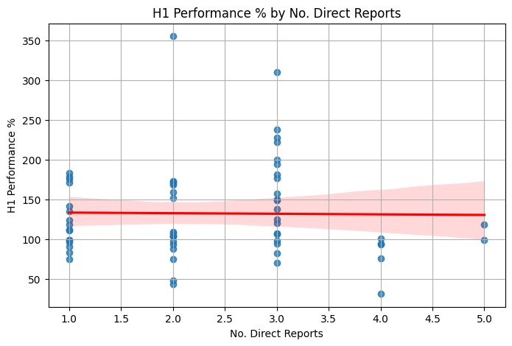
Correlation
The Pearson correlation coefficient was approximately 0, indicating:
- No linear relationship between team size and performance
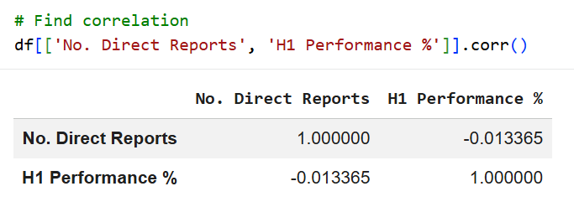
Regression Model
A simple linear regression model was built:
$$\hat{y}=β_{0}+β_{1}X$$
Where:
- $X$= number of direct reports
- $\hat{y}$= predicted H1 performance
Model Performance (How Good is the Model?)
Once the regression model was built, it was important to evaluate how accurate its predictions were. To do this, three key metrics were used:
1. R² Score (How much does the model actually explain?)
Result: ~0.0002
Here, the R² score tells us:
“How much of the variation in performance can be explained by the number of direct reports?”
- A value of 1 means the model perfectly explains performance
- A value of 0 means the model explains nothing at all
In this case, R² is approximately 0.
Plain English interpretation:
The number of direct reports tells us almost nothing about a manager’s performance. You could remove the “No. Direct Reports” column entirely and the model would perform almost the same.
2. Mean Absolute Error (MAE) – Average prediction error
Result: ~0.45 (≈ 45 percentage points)
MAE measures:
“On average, how far away are our predictions from the actual performance?”
This shows that this model is off by ~45 percentage points on average.
Plain English interpretation:
If a manager actually performs at 120%, the model might predict something like 75% or 165%. That’s a very large error, which shows the model isn’t reliable.
3. Root Mean Squared Error (RMSE) – Penalises large errors more
Result: ~0.58 (≈ 58 percentage points)
RMSE works similarly to MAE but penalises large mistakes more heavily. This is useful because, in real data, very bad predictions matter more than small ones.
Plain English interpretation:
Not only is the model inaccurate on average but it also makes some very large mistakes. This suggests the relationship between team size and performance is extremely weak or non-existent.
Overall Model Interpretation
Putting these metrics together:
- R² ≈ 0 → no explanatory power
- MAE ≈ 45% → large average errors
- RMSE ≈ 58% → errors vary widely and can be extreme
Final takeaway:
The model is not useful for prediction. It performs no better than simply guessing an average performance for all managers.
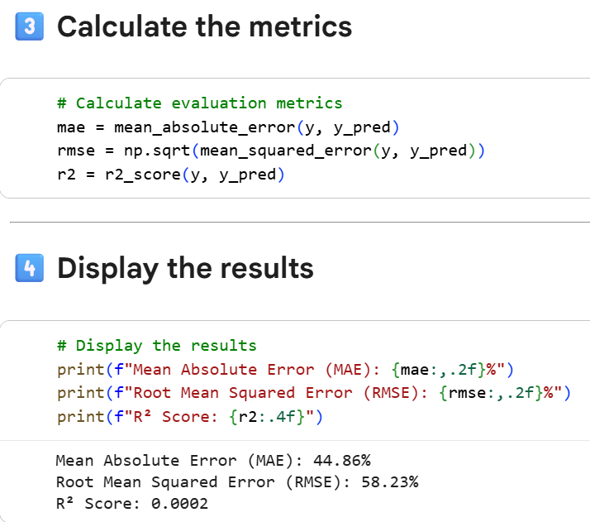
Analysis 2: H1 Performance by Office
Objective
To determine whether performance varies significantly across office locations.
Exploratory Analysis
Two visual approaches were used:
- Box plots - show distribution of performance within each office. They highlight median, spread, and outliers
- Bar charts - show average performance per office
Observations
- Median performance is broadly similar across offices
- There is significant overlap in performance distributions
- Some offices show more variability, but no consistent trend
Statistical Test (ANOVA)
A one-way ANOVA test was used to compare mean performance across offices.
Result:
- p-value ≈ 0.455
Interpretation
- The p-value is well above 0.05
- This means there is no statistically significant difference between offices
Conclusion:
Office location does not meaningfully influence H1 performance.
Overall Conclusions
Across both analyses:
1. No relationship between team size and performance
- Increasing direct reports does not improve or reduce performance
- Performance outcomes vary independently of team size
2. No significant differences between offices
- Performance is consistent across locations
- Any observed variation is due to individual differences, not location
Key Takeaway
Neither team size nor office location are strong predictors of performance. This suggests that performance is driven more by individual or operational factors, rather than structural ones.
Recommendations for Future Analysis
To better understand performance drivers, future work should include:
- Additional variables such as:
  - Tenure in role
  - Historical performance trends
  - Sales activity metrics
  - Team composition
  - Manager experience
- Moving from simple regression to Multiple Linear Regression (MLR), where multiple predictors are analysed together
This would provide a more complete understanding of what drives high performance.

